**Screenshots**

Console Output Window to display the output of the project

1. **To add player:**

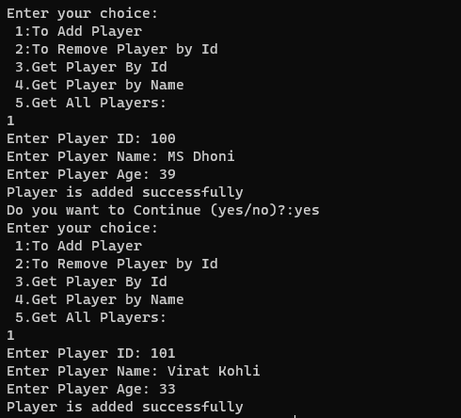

1. **To remove a player by passing the Player Id:**

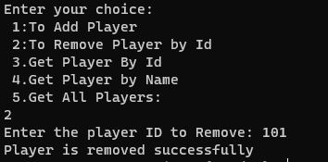

1. **To get player details by passing the Player Id:**

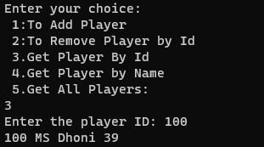

1. **To get player details by passing the player’s name:**

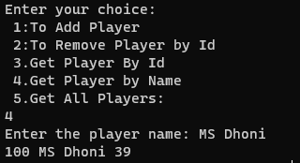

1. **To get all player details currently present in the team:**

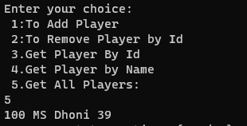

1. **Full output window with all inputs and outputs:**

